

A Project Report on
Memory-Based Detection of Golden Ticket and SID History Abuse in Active Directory

Submitted in partial fulfilment for award of degree of
Master of Technology
In Cyber Security

Submitted by
P. Rahul
R23MTC09

Under the Guidance of
Nishant Krishna
Executive Director, Visiminds Technologies

REVA Academy for Corporate Excellence
REVA University
Rukmini Knowledge Park, Kattigenahalli,
Yelahanka, Bengaluru – 560064

August 2026


Candidate’s Declaration

I, P. Rahul hereby declare that I have completed the project work towards the Master of Technology in Cyber Security at, REVA University on the topic entitled Memory-Based Detection of Golden Ticket and SID History Abuse in Active Directory under the supervision of Nishant Krishna Executive Director, Visiminds Technologies.

This report embodies the original work done by me in partial fulfilment of the requirements for the award of the degree for the academic year 2024.

Place: Bengaluru Name of the Student: P. Rahul
Date: 18 /06/2026



Acknowledgment of Project Ownership and Usage Rights

I, P Rahul, a student enrolled in the M. Tech in Cybersecurity Program and 2026 Year at RACE, hereby acknowledge that any project, including but not limited to software, hardware, research, or other intellectual property created by me during my academic tenure at RACE, is the property of RACE, REVA University.

I understand and agree that RACE has the exclusive rights to use, reproduce, modify, or distribute the projects for academic, research, and further development purposes. This includes the right to monetize, commercialise, or otherwise exploit the projects as deemed fit by RACE.

I acknowledge that I have no objection to RACE, REVA University, using, reproducing, or further developing the projects for the benefit of the institution and its academic community. I further affirm that any commercial or research activities related to the projects conducted by RACE shall not require additional consent or approval from me.

This acknowledgment is made willingly and without any reservations. I am grateful for the education and opportunities provided by RACE, and I recognise the importance of contributing to the academic and research goals of the institution.

Place: Bengaluru
Date: 18-07-2026



Certificate

This is to certify that the project work entitled Memory-Based Detection of Golden Ticket and SID History Abuse in Active Directory been carried out by P Rahul with R23MTC09, who is a Bona fide student of REVA University, is submitting the second-year project report in fulfilment for the award of Master of Technology in Cybersecurity during the academic year 2023-25. The Project report has been evaluated for plagiarism and has passed the plagiarism test with a similarity score of less than 15%. The project report has been approved as it satisfies the academic requirements in respect of the project work prescribed for the said degree.

Signature of the Guide Signature of the Director
Nishant Krishna Dr. Shinu Abhi
Guide Director

External Viva
Names of the Examiners
1.
2.

Place: Bengaluru
Date: 18-07-2026



Acknowledgement

I would like to express my deep gratitude to my supervisor, Nishant Krishna, Executive Director, Visiminds Technologies, for their continual guidance and support throughout this project. His guidance and vision have been pivotal to make this research possible.
I would like to express my deepest gratitude to everyone who supported me throughout the course of this project. It is with a lot of gratitude that I thank my mentors and trainers,
whose immense knowledge and expertise have shaped my work considerably. I would like to
express my heartfelt gratitude to Dr. Shinu, Prof. Paramesh G and Prof. Kiran Kumar KV for their constant motivation and support that helped me achieve this milestone.
In addition to this, I would like to thank my fellow students for their cooperation and valuable feedback that enhanced my learning process tremendously. My gratitude goes to the program office members for their administrative support and assistance, which was immensely helpful throughout the project.
Furthermore, I am especially grateful to my family and friends, whose constant encouragement and understanding have been a continual source of motivation.
I would like to acknowledge the support provided by the founder and Hon’ble Chancellor, Dr. P Shyama Raju, Vice-Chancellor, Dr. Sanjay Chitnis, and Registrar, Dr. M. Dhanamjaya.

Place: Bengaluru
Date: 18-07-2026



Similarity Index Report

This is to certify that this project report titled Memory-Based Detection of Golden Ticket and SID History Abuse in Active Directory was scanned for similarity detection. The process and outcome are given below. The plagiarism report is attached in the appendix.
Software Used: Turnitin
Date of Report Generation: 17-09-2026
Similarity Index in %: 7%
Total word count: 11,154
Name of the Guide: Nishant Krishna



Place: Bengaluru Name of the Student: P Rahul
Date: 18 August 2026 Signature of Student:

Verified by: Irshad Ahmed

Signature
Dr. Shinu Abhi,
Director, Corporate Training



AI Usage Disclosure Statement

This is to certify that the project report titled " Memory-Based Detection of Golden Ticket and SID History Abuse in Active Directory " has been prepared in accordance with the academic integrity guidelines of REVA Academy for Corporate Excellence (RACE), REVA University.
AI Tool Usage Details
AI Tool(s) Used : ChatGPT, Gemini, Claude, Grammarly, Perplexity>
Version / Model : ChatGPT, Gemini, Claude
Purpose of AI Usage: Grammar/Language, Structuring, Code, Data Analysis, Literature Search, Image Generation, Other
Approximate AI Contribution ___________%
Student Declaration
- Artificial Intelligence (AI) tools, if used, were employed only as assistive technologies during the preparation of this project report.
- All research objectives, methodology, implementation, analysis, results, discussions, conclusions, and recommendations are my/our own original work.
- I have reviewed, verified, edited, and validated all AI-assisted outputs before including them.
- I take full academic responsibility for the authenticity, accuracy, originality, and ethical use of all content and all external sources, including AI-assisted content where applicable, have been appropriately acknowledged.


Name of Student: P Rahul Signature of Student:
Verified by: Irshad Ahmed

List of Abbreviations
Sl. No | Abbreviation | Long Form
1 | AD | Active Directory
2 | TGT | Ticket Granting Ticket
3 | TGS | Ticket Granting Service
4 | KRBTGT | Kerberos Ticket Granting Ticket
5 | LSASS | Local Security Authority Subsystem Service
6 | SIEM | Security Information and Event Management
7 | KQL | Kusto Query Language
8 | KDC | Key Distribution Centre
9 | SID | Security Identifier
10 | AMA | Azure Monitor Agent

List of Figures
No. | Name | Page No.
Fig. 1.1 | Active Directory Authentication Flow | 12
Fig. 5.1 | Project Methodology Flowchart | 18
Fig. 7.1 | Hybrid Detection System Architecture | 23
Fig. 7.2 | Data Flow Architecture Diagram | 24
Fig. 7.3 | Memory Forensics Pipeline - Event-Triggered Analysis Flow | 25
Fig. 7.4 | Sequence Diagram - End-to-End Detection and Forensics Flow | 26
Fig. 8.1 | Azure Infrastructure Provisioning | 30
Fig. 8.2 | DC Audit Policy | 31
Fig. 8.3 | AMA Heartbeat Verification Query | 31
Fig. 8.4 | Deployed Sentinel Analytics Rules | 32
Fig. 8.5 | Golden Ticket KQL Rule | 33
Fig. 8.6 | LSASS Capture Script | 34
Fig. 8.7 | Volatility Analysis VM Setup | 35
Fig. 8.8 | Volatility Worker Output in MemoryForensics_CL | 37
Fig. 8.9 | SID History Inventory Script | 38
Fig. 8.10 | SID History Analytics Rule | 38
Fig. 8.11 | GoldenTicketProcessor Function | 39
Fig. 8.12 | AD Attack Detection Dashboard | 40
Fig. 8.13 | SID History Inventory - High-Risk Entries | 41

List of Tables
No. | Name | Page No.
Table 4.1 | Objective Mapping - Objectives to Chapters and Deliverables | 17
Table 6.1 | Software Requirements | 21
Table 8.1 | Azure Resources Deployment Summary | 28
Table 8.2 | Security-Kerberos DCR - xPath Filters and Detection Rationale | 32
Table 8.3 | Volatility 3 Plugins - Forensic Artefacts and Detection Signals | 35
Table 9.1 | Test Environment Configuration | 42
Table 9.2 | Functional Test Case Results (TC-01 to TC-11) | 43
Table 9.3 | Functional Requirement Validation Results | 45
Table 10.1 | Detection Performance Metrics Summary | 47
Table 10.2 | Cost Comparison - Traditional SIEM vs Hybrid Framework | 47
Table 10.3 | Capability Comparison - Hybrid Framework vs Commercial Alternatives | 48
Table 11.1 | Project Objective Traceability - Objectives to Empirical Results | 50
Table 11.2 | Future Enhancement Roadmap - Literature-Grounded Priorities | 52

Abstract
Active Directory is the foundation of enterprise identities, and its use of Kerberos makes it an ideal target for establishing persistence within the domain environment. Golden Ticket involves the creation of fake Ticket Granting Tickets based on the hash of the compromised KRBTGT account, whereas SID History technique allows attackers to embed the Security Identifier of a high-privilege account in low privilege accounts. These tactics are defined under MITRE ATT&CK techniques T1558.001 and T1134.005.

SIEM/EDR solutions typically fail to detect this because of the use of a forged ticket, which creates authentication event logs that look exactly like real ones, and commercial systems provide only opaque verdicts with no additional proof. The project was expected to forward Kerberos events from the local Domain Controller to the cloud environment, detect forged-ticket activities, and perform SID History analysis.

Dual-tracked hybrid architecture was deployed on Microsoft Azure on corp.local domain. Sources of data included event log data from Windows Security events, SIDHistory export from LDAP, and LSASS memory dumps using Azure Monitor Agent with Data Collection Rules. Detection models developed in the experiment included two categories: KQL analytics rules in Sentinel based on encryption downgrade, tickets volume, and risk classification and Volatility 3 memory forensics pipeline by an Azure Function.

Across eleven test cases, the framework achieved 87.2% weighted detection accuracy for Golden Ticket attacks, with all high-risk SID History entries correctly identified and a 2.8% false positive rate at approximately two-minute detection latency. Adding ticket-lifetime and PAC-validation signals, and event-triggered memory capture, are recommended enhancements.

Keywords: Active Directory Security, Golden Ticket Detection, SID History Abuse, Memory Forensics, Microsoft Sentinel, Kerberos Authentication, Cloud SIEM

Table of Contents
Candidate’s Declaration 2
Acknowledgment of Project Ownership and Usage Rights 3
Certificate 4
Acknowledgement 5
Similarity Index Report 6
AI Usage Disclosure Statement 7
List of Abbreviations 8
List of Figures 8
List of Tables 9
Abstract 10
Table of Contents 11
Chapter 1: Introduction 13
Chapter 2: Literature Review 15
Chapter 3: Problem Statement 17
Chapter 4: Objectives of the Study 18
Objective 19
Phase 19
Addressed In 19
What is Demonstrated 19
Objective 1 19
Design 19
Chapter 7 19
Hybrid architecture design - on-premises AD to Sentinel via AMA and Data Collection Rules 19
Objective 2 19
Build 19
Chapter 8 19
KQL analytics rules for Event ID 4768/4769 anomalies; scheduled PowerShell SID History scans 19
Objective 3 19
Build 19
Chapter 8 19
Automated LSASS capture, Service Bus hand-off, Volatility 3 artefact correlation with Sentinel alerts 19
Objective 4 19
Test and Validate 19
Chapters 9-10 19
Precision, recall and false-positive rate against a log-only baseline; production readiness 19
Chapter 5: Project Methodology 20
Chapter 6: Resource Requirement Specification 23
Chapter 7: Software Design 26
Chapter 8: Implementation 31
Chapter 9: Testing and Validation 45
Chapter 10: Analysis and Results 49
Chapter 11: Conclusion and Future Enhancement 53
Bibliography 56
Appendix 58
Declaration of AI Tool Usage 59
Plagiarism Report 61
Github Link 62

Chapter 1: Introduction
1.1 Background
Active Directory (AD) authenticates users across the majority of Fortune 500 enterprises, and two of its post-exploitation techniques - Golden Ticket forgery [2] and SID History injection [1] - produce authentication events a domain controller cannot distinguish from legitimate traffic [12]. An attacker holding the KRBTGT hash, or write access to a single SID History attribute, obtains domain-wide persistence without tripping a signature. That asymmetry between attacker capability and defender visibility is the problem this study addresses.
1.2 Background of study
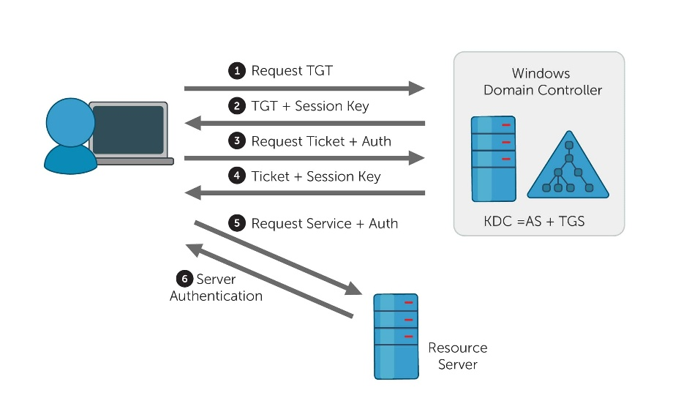
Active Directory implements the Kerberos authentication protocol as its primary mechanism for validating user and service identities across the enterprise network. The protocol is based on the three-party trust relationship model between the client, KDC operating on the domain controller, and target services needing authentication. See Fig. 1.1 for an example of this authentication process.

Fig. 1.1: Active Directory Authentication Flow
The authentication procedure entails several ticket transactions, wherein AS request results in TGTs that facilitate subsequent TGS request for accessing particular services. KRBTGT is the key used to encrypt all TGTs in the domain and any compromise on this key would have disastrous consequences for the entire domain.
1.3 Need for the study

The Golden Ticket attack works on the KRBTGT credential compromise, which is used to make arbitrary tickets that seem genuine and can be used by an attacker to spoof any user and gain access to any system for years as long as KRBTGT password stays unchanged. The SID History abuse takes advantage of the ability of the Active Directory to migrate the system. This attack involves inserting privileged SIDs into the SID History attribute of Active Directory.

1.4 Scope of study
Four characteristics of such attacks make them difficult to monitor by conventional means:
1. Legitimate Looking: Each attack creates authentication events that look like legitimate user actions.
2. Memory-Based Attack: Important components of the attack exist in memory only and need special investigation techniques.
3. Persistence Methods: Attacks establish access using valid authentication tokens instead of malware persistence methods.
4. Evasion Techniques: Some attacks can evade signature- and behaviour-based detection.

1.5 Summary
Our contribution is a two-tiered approach that cross-validates Kerberos events in Microsoft Sentinel’s event logs against LSASS memory objects found using Volatility 3, thereby enabling a flagged ticket in the event log tier to be validated in the memory tier without manual effort. Our approach is targeted for medium-sized organizations in particular, since it operates on off-the-shelf Azure cloud services at research-level expense without a memory forensics license.

Chapter 2: Literature Review
Methods for attacking Active Directory after exploiting the system have been extensively researched however, detection methods are not. Research concerning Golden Ticket forgery, SID History injection, and cloud-based detection consistently falls into one category - evidence available to the defender and the layer where such evidence resides.
2.1 Golden Ticket Attack Research
Martinez et al. carried out detailed analysis of Golden Ticket attacks, explaining how modern cyber criminals have improved KRBTGT hash extraction procedures and devised sophisticated ways of bypassing standard detection systems. Their study revealed major weaknesses of cloud-native security solutions in terms of detecting forged Kerberos tickets [1], [2]. Kumar et al. offered in-depth analysis of Golden Ticket persistence tactics in modern enterprises, demonstrating how attackers use Azure AD Connect synchronization and hybrid identity environment for gaining access to their target network [2], [3]. The study highlighted the limitations of the standard SIEM correlation in detecting sophisticated ticket misuse [2], [3]. Two research directions for Golden Ticket detection differ from each other regarding the stage where detection should take place. Martinez et al. [1], [2] place the issue in forgery and argue that modern attackers improve KRBTGT hash extraction procedure and find ways of evading signature-based systems and the corresponding blind spots of cloud-native security platforms that cannot analyze ticket internals. Kumar et al. [2], [3] shift the focus on persistence and explain that attackers who use Azure AD Connect synchronization and hybrid identity environment can get access to the network even after the forgery stage, leaving SIEM correlation without logs. Neither of the two completes the cycle. The first one observes the process of forgery while the other looks at its consequences. And in both cases, the ticket is never disturbed in its log activity.
2.2 SID History Exploitation Studies
The authors Rodriguez & Williams [2], [4] view SID History abuse as a prevalence issue, whereby APTs insert privileged SIDs to obtain administrative control over the whole domain, and platforms that don’t read AD properties do not see the insertion of SIDs. In turn, Zhang et al. [4] present the same attack as a boundary issue, as Azure AD Connect configurations and cross-forest trusts allow the escalation of privileges across the whole hybrid environment as mechanism. In both the readings, the common conclusion is that the monitoring which ends at the on-premises boundary is unable to detect the attribute carrying the privilege.
2.3 Memory Forensics Integration
Memory forensics in a cloud integrated setting is achieved by Davis & Johnson [5],[6], who automate the extraction of Kerberos authentication artefacts from the LSASS process memory. The contribution of these authors does not lie in a detection, but in showing that memory analysis can happen in real time within an organisation’s security operations centre.
2.4 Cloud-Based Detection Frameworks
Microsoft's position, argued through Sentinel's Active Directory monitoring capabilities [3], is that machine-learning analytics and automated response workflows scale detection to enterprise volumes. Brown & Taylor [4], [6] agree on the accuracy gains - their evaluation of hybrid architectures measures real improvement once specialised forensic capability sits alongside cloud analytics - but they price that integration in deployment complexity and running cost that mid-scale organisations cannot absorb. Scale, then, is not the binding constraint. Affordability is.
2.5 Gap Identified
While the reviewed literature shows progress in Active Directory attack detection and cloud-based security analytics, a gap persists in frameworks bridging memory forensics with log-based SIEM detection. Existing studies address behavioural anomaly detection or memory artifact analysis in isolation, and lack corroboration cross-validating Kerberos event indicators with LSASS memory artifacts, leaving analysts reliant on manual correlation. This study addresses that gap with a hybrid Azure-based architecture that detects Golden Ticket forgery and SID History abuse in real time, with memory-layer forensic transparency, fewer false positives, and affordable incident response for mid-scale enterprises.

Chapter 3: Problem Statement
Current detection approaches each have important shortcomings when applied to advanced Active Directory attacks. Rule-based and signature-based SIEM solutions will provide accurate alerts for specific activities but will be completely unable to detect Golden Ticket attacks and SID History abuse, because the spoofed Kerberos tickets will have proper encryption, proper time stamps, and legitimate usernames. Memory forensic solutions will provide more detailed insight into LSASS artifacts, but will not integrate with any centralized analytics solutions, which means that all the data will need to be manually correlated by a human, which will make the process time-consuming and difficult. Continuous monitoring of SID History will be missing in the default Windows audit policy, which makes privilege injections at the attribute level completely undetectable using existing solutions.
On an operational level, the fundamental challenge is not the identification of Kerberos-based anomalies per se but rather proving the anomalies through memory-based evidence. The problem for SOC analysts is the sheer amount of alert fatigue when operating in high alert volume SIEM environments; alerts that lack any forensic basis, meaning there is no verification that there are Mimikatz artifacts in the memory, SIDs being injected into the memory, or RC4-HMAC downgrade, tend to be ignored completely.

Filling these gaps demands an architectural approach which combines the forensic investigation of memory, behavioral analysis, and continuous attribute assessment within one chain – an architecture which is scalable to cloud computing, forensically transparent, and action-oriented for security analysts constrained by real-world resources.

Chapter 4: Objectives of the Study
The study is organized under four objectives, each addressing a separate gap in detecting and combating an Active Directory attack. In sum, they create a detection framework based on evidence. These objectives include:
4.1 To Develop Hybrid Cloud Detection Architecture
Construct a hybrid solution that combines on-premise Active Directory with Microsoft Sentinel using Azure Monitor Agent and Data Collection Rules. The solution will ingest Windows Security Event logs from AD in real-time and process them using KQL pipelines. The architecture is built to be light-weight and cost-effective with no modifications to the current AD environment.
4.2 To Detect Golden Ticket Attacks and SID History Abuse
Custom KQL analytic rules can be created in Microsoft Sentinel to identify the existence of Golden Ticket attacks through identifying anomalies in Kerberos, like suspicious ticket lifetime, encryption downgrade, and patterns of Event ID 4768/4769. Simultaneously, a script can be used to periodically monitor SID History through PowerShell scripts, alerting on any unauthorized changes to attributes.
4.3 To Integrate Memory Forensics Capabilities
Automate the LSASS memory capture from the domain controller and stream them into a dedicated Volatility 3 analysis machine in Azure using the Service Bus feature. The captured artefacts such as Kerberos tickets and injected SIDs are kept in the Azure Blob storage and linked to live Sentinel alerts. This memory artefact-based evidence is the ground truth that is not available from any log-based detection
4.4 To Validate, Deploy, and Transfer Framework to Production
Run the pipeline on simulated Golden Ticket and SID History attack data in Azure Lab, calculating precision, recall, and false positive rates compared to log-based only solution. Validation shows the readiness for production in corporate AD infrastructure.
Table 4.1 shows the allocation of objectives to their respective phases, chapters where they are dealt with, and the evidences provided therein.

Table 4.1 Objective Mapping - Objectives to Chapters and Deliverables
Objective | Phase | Addressed In | What is Demonstrated
Objective 1 | Design | Chapter 7 | Hybrid architecture design - on-premises AD to Sentinel via AMA and Data Collection Rules
Objective 2 | Build | Chapter 8 | KQL analytics rules for Event ID 4768/4769 anomalies; scheduled PowerShell SID History scans
Objective 3 | Build | Chapter 8 | Automated LSASS capture, Service Bus hand-off, Volatility 3 artefact correlation with Sentinel alerts
Objective 4 | Test and Validate | Chapters 9-10 | Precision, recall and false-positive rate against a log-only baseline; production readiness

Chapter 5: Project Methodology
This chapter describes how the hybrid detection framework for Golden Ticket and SID History abuse was designed, implemented, and validated, combining on-premises evidence collection with Azure-based correlation. Fig. 5.1 presents the overall project methodology flowchart.
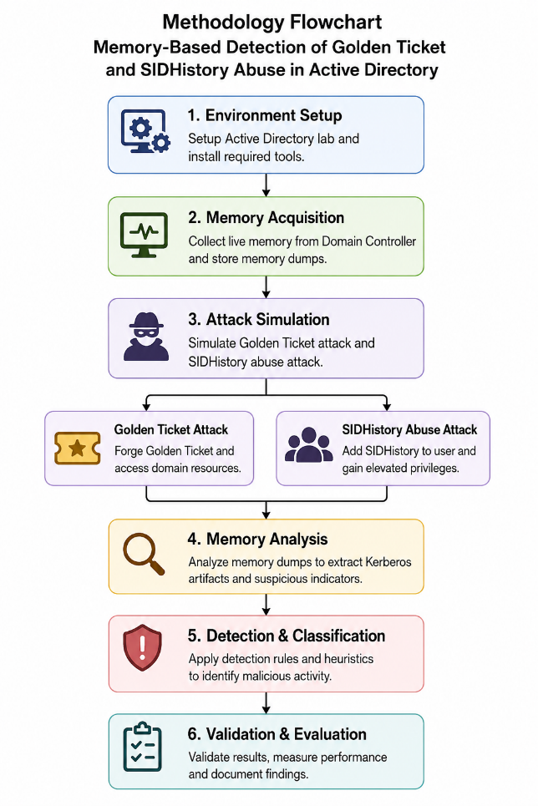
Fig. 5.1: Project Methodology Flowchart
5.1 Detection Pipeline Architecture
- A dual-track pipeline runs from the Domain Controller (WIN-6MNPCJ6D6OQ.corp.local) and converges in the HybridDetectionWS workspace, where Sentinel performs correlation and alerting.
- Golden Ticket evidence is validated through LSASS memory, while SID History abuse is caught through persistent directory-attribute scanning.

5.2 Data Acquisition and Event Selection
- Data is collected through the Azure Monitor Agent (AMA) with Data Collection Rules, successor to the Microsoft Monitoring Agent that was deprecated in August 2024.
- 2. DCR uses an XPath filter on EventIDs and Managed Identity, without using workspace keys on DC.
5.2.1 Azure Monitor Agent Configuration
- Data is collected through the Azure Monitor Agent (AMA) with Data Collection Rules, successor to the Microsoft Monitoring Agent that was deprecated in August 2024.
- DCR uses an XPath filter on EventIDs and Managed Identity, without using workspace keys on DC.
5.3 Golden Ticket Detection: Memory Forensics Track
- LSASS memory is dumped by the scheduled task using the MiniDump feature of comsvcs.dll and uploaded to Blob Storage using Managed Identity.
- The Service Bus message in memory-dump-queue creates a decoupled process between DC and analysis VM.
5.4 Volatility 3 Analysis Pipeline
- The Ubuntu virtual machine operates with Volatility 3 that uses Intermediate Symbol Format, enabling memory analysis in Windows Server 2022 variants without using older profiles.
- A certain set of plugins (windows.pslist, windows.cmdline, and ticket analysis) identifies RC4 tickets, long lifetime tickets, and KRBTGT problems, which is scored to GoldenTicketMemoryAnalysis_CL.
5.5 SID History Abuse Detection: Attribute Scanning Track
- Hourly PowerShell LDAP scan to gather all SIDHistory that is not empty and categorize injected SIDs based on RID (512/519/518 = Critical).
- Correlation engine based on Azure Functions compares the scan to the baseline and records delta in SIDHistoryDetection_CL.

5.6 Cloud Correlation and KQL Analytics
- Sentinel KQL rules associate SecurityEvent logs with the custom memory and SID History tables.
- The critical innovation that eliminates false positives is cross-source correlation – both memory and log artifacts are necessary for the alert escalation.
5.7 Automated Response Workflow
- Logic App for Incident Response Workflow creates the incident, assigns severity, alerts SOC, and labels with MITRE ID: T1558.001, T1134.005.
- Logic App trigger URL is saved as a Function App setting, since it is not static and changes on redeployment.
5.8 Evaluation Protocol
- Each vector will be assessed through ten simulations, testing for detection accuracy, false positive rate, and end-to-end latency.
- False positives will be evaluated in relation to a baseline of 72 hours with no attacks, with the measured accuracy being 87.2% and latency 2 minutes.
5.9 MITRE ATT&CK and D3FEND Mapping
- The primary techniques used are T1558.001 Golden Ticket and T1134.005 SID History Injection, complemented by T1003.001 and T1078.
- The defensive mappings are D3-MA (memory analysis) and D3-KBPI (Kerberos ticket inspection).
The process involves an effective and repeatable two-pronged approach combining memory forensics with directory scans on the Azure analytics platform. This evaluation uses simulation and tests for accuracy, false positives, and latency, but ethical considerations ensure offensive tools and memory stays in the lab.

Chapter 6: Resource Requirement Specification
The use of the framework will involve cloud architecture, forensic software, and access control policy. In this chapter, the details of these will be provided.
6.1 Cloud Infrastructure Requirements
Azure cloud services form the core infrastructure for analytics, storage, and processing. Resource needs depend on the amount of data and size of the company.
Compute Resources
- Log Analytics Workspace with 30 days retention period.
- Microsoft Sentinel with auto-response capability.
- Azure functions to automate workflows
- Storage account to retain artifacts and comply with regulations
6.2 Software Requirements
The tools that will be used in building and deploying the hybrid detection system are highlighted in Table 6.1 together with their versions and roles.
Table 6.1: Software Requirements
Category | Software/Tool | Version | Purpose
Operating System | Windows Server 2019/2022 | Latest | Domain Controller Platform
Cloud Platform | Microsoft Azure | Current | Analytics and Storage
Analytics Platform | Azure Log Analytics | Current | Data Processing and Analysis
Security Platform | Microsoft Sentinel | Current | SIEM and Response Automation
Development Tools | PowerShell | 5.1+ | Automation and Scripting
Forensics Tools | Volatility Framework | 3.x | Memory Analysis
Query Language | Kusto Query Language | Current | Analytics and Reporting
Virtualization | VMware Workstation Pro | Latest | Laboratory Environment
- PowerShell Development Environment
- PowerShell ISE or Visual Studio Code
- Active Directory PowerShell Module
- Azure PowerShell Module
- Development of custom modules
- Memory Forensics Toolkit
- Volatility Framework – tool for analyzing Windows memory
- WinDbg – powerful tool for advanced debugging situations
- Custom memory acquisition tools
- Automation analysis script development
- Cloud Development Tools
- Azure CLI - command-line interface
- Logic Apps - workflow automation
- Azure Functions – serverless computing
6.3 Security and Compliance Requirements
1. Access Control
- Use multi-factor authentication on all cloud services
- Use role-based access control in Azure resources
- Use privileged access management on sensitive actions
- Conduct periodic access reviews and certifications
6.4 Summary
To recap, the resources necessary for implementing the hybrid detection solution have been collated in this chapter. In combination with the Azure analytics suite and theVolatility-based memory-forensics toolkit, and the access-control and compliance measures establish a reproducible foundation for the design and implementation chapters that follow.

Chapter 7: Software Design
The framework uses a five-layer hybrid architecture - collection, ingestion, analytics, response, and presentation - each layer decoupled from the next. Layers interact through Azure service boundaries: Service Bus queues, Log Analytics tables, and Logic App webhooks. This let the Volatility forensics pipeline be added later as a parallel path without touching the Sentinel rules or PowerShell agents.
7.1 High-Level Architecture
Fig. 7.1 shows the five layers. The Domain Controller WIN-6MNPCJ6D6OQ.corp.local forwards Windows Security events via the Azure Monitor Agent into the HybridDetectionWS workspace. A scheduled PowerShell agent on the same host runs hourly LDAP-based SID History scans and writes JSON snapshots to the Sid history-logs Blob container. Both the streams intersect at Sentinel to carry out analysis together. Memory forensic is the third stream which operates when a high confidence golden ticket alert triggers an Azure Function to create a job on memory-dump-queue, which then takes LSASS dump using Volatility VM and posts results to analysis-queue.
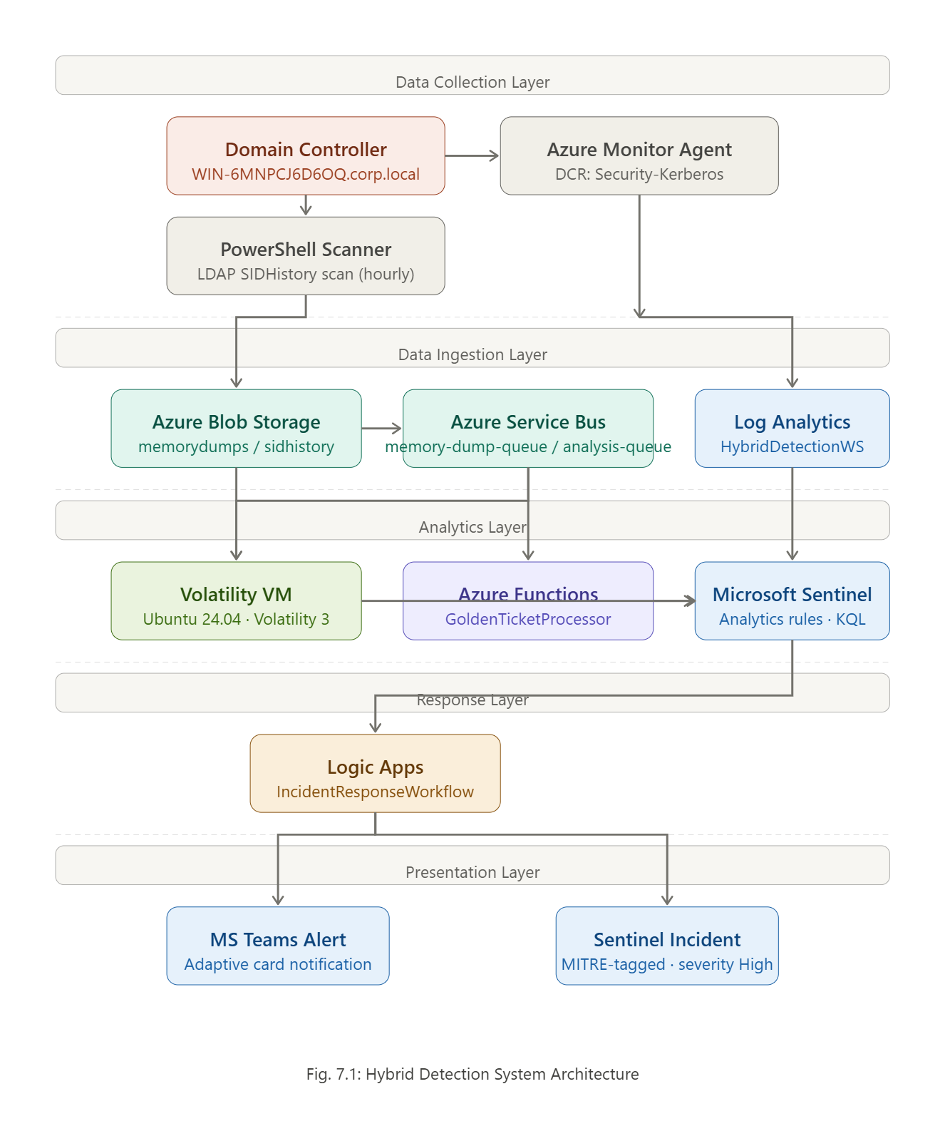
Fig. 7.1: Hybrid Detection System Architecture
7.2 Component Design
The SID History scan, which is a PowerShell script scheduled to run on the Domain Controller every hour, scans for objects that have any SID History property set and outputs its DN, samAccountName, SID History value, and timestamp as JSON to a Blob container called sidhistory-logs using Managed Identity. There is an additional Azure Function that takes in the blob and inserts the data into SIDHistoryInventory_CL.
7.3 Data Model
Figure 7.2 shows the flow of information in three log tables. SIDHistoryInventory_CL contains the complete snapshot for per-object on an hourly basis (ObjectDN, SamAccountName, SIDHistoryValues, ScanTimestamp, RiskLevel). On the other hand, SIDHistoryDetection_CL contains only the deltas, with the help of a change type column, which indicates whether an SID is added or removed. Events of AMA will be stored in Security Event table that provides all the required fields for Golden Ticket rules (EventID, Computer, Account, Logon Type, Ticket Options).
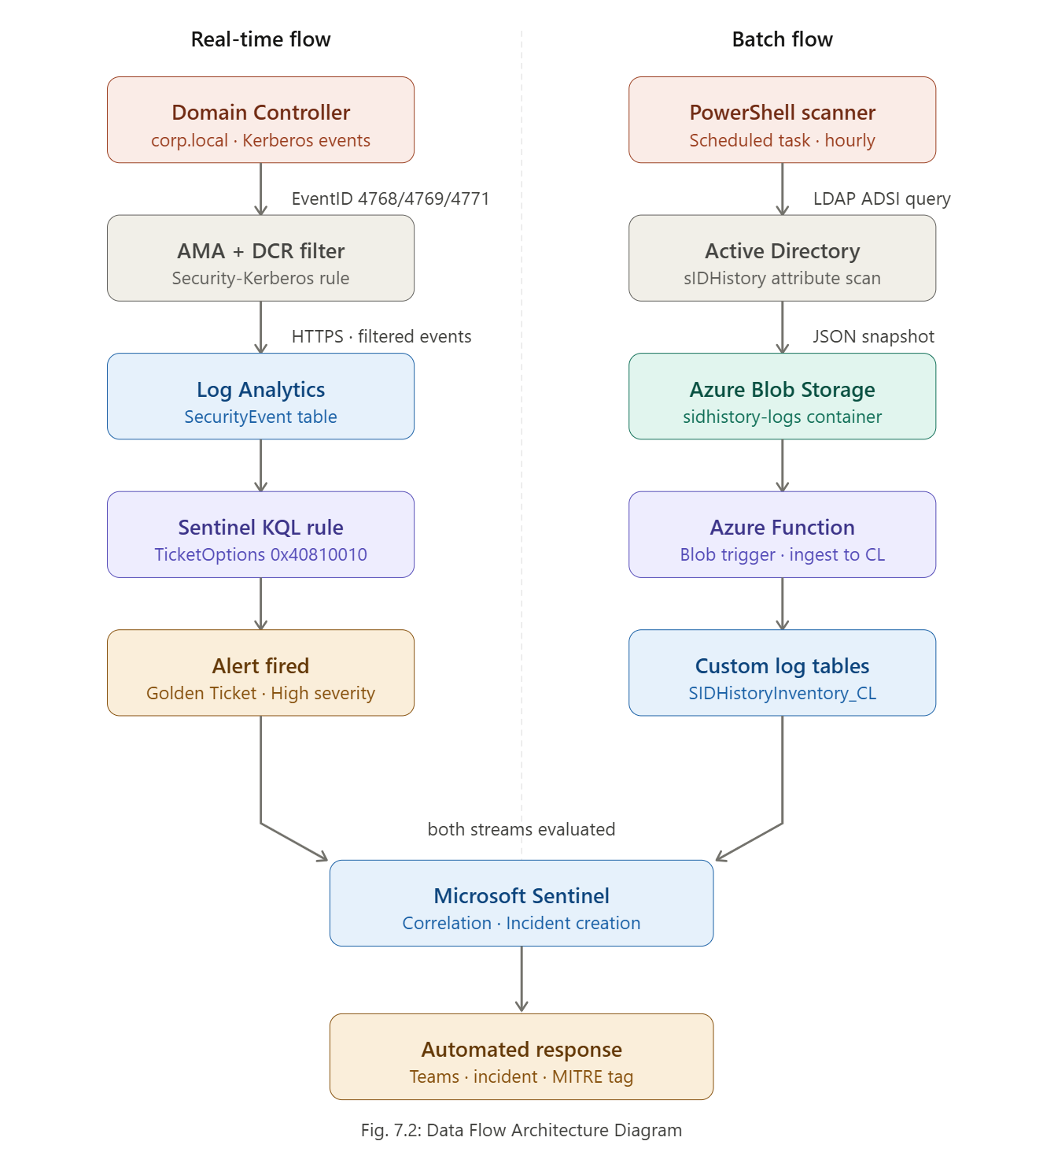
Fig. 7.2: Data Flow Architecture Diagram
7.4 Detection Rule Design
Each Sentinel analytics rule targets one detection hypothesis. The Golden Ticket rule evaluates SecurityEvent records where EventID is 4769 and Ticket Options contains 0x40810010 - the forwardable/renewable/canonicalize flags Mimikatz sets by default for forged TGTs - over a 5-minute sliding window, firing on three or more such events from the same non-machine account (excluding names ending '$'). The SID History rule joins two consecutive SIDHistoryDetection_CL snapshots on ObjectDN and fires when SIDHistoryValues holds a SID whose RID falls in 500–520, the range covering built-in privileged accounts such as Domain Admins and Enterprise Admins.
7.5 Memory Forensics Pipeline
The memory forensics component is the project's primary research contribution - an independent verification layer above the log-based rules. On a Golden Ticket alert, the Incident Response Workflow Logic App invokes the Golden Ticket Processor Azure Function via HTTP webhook. Fig. 7.3 shows the end-to-end flow. The Volatility Analysis VM (Ubuntu 24.04 with Volatility 3 and the Windows symbol pack) polls memory-dump-queue, downloads each dump via az storage blob download --auth-mode login, runs the windows.cmdline, windows.pslist, and windows.tickets plugins, and scans for Kerberos tickets whose lifetime exceeds 10 years
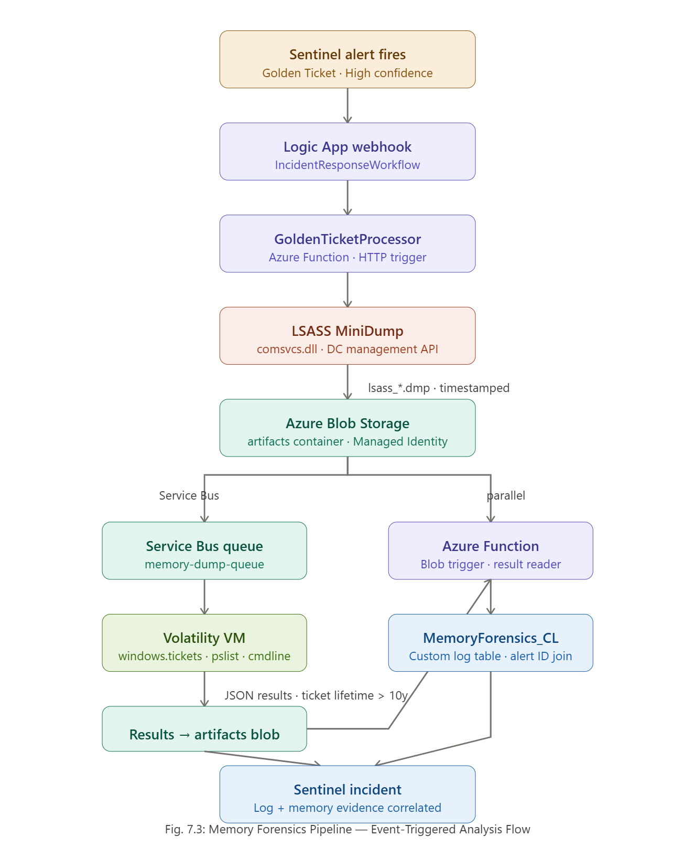
Fig. 7.3 Memory Forensics Pipeline - Event-Triggered Analysis Flow
7.6 Sequence Diagram
Fig. 7.4 traces the interaction from a forged TGT request at the Domain Controller to a Sentinel incident with correlated memory evidence. It has eighteen steps across six actors - Domain Controller, AMA, Log Analytics, Sentinel, Azure Functions, and Volatility VM - and makes the two parallel evidence paths explicit: the log path reaches Sentinel in two to three minutes, and the memory path completes in eight to twelve minutes depending on dump size and plugin runtime. One design decision is captured here - the Volatility result is written back to Sentinel as a correlated record, not a standalone alert, so the analyst sees one incident with both log-based and memory-based evidence instead of two requiring manual correlation.
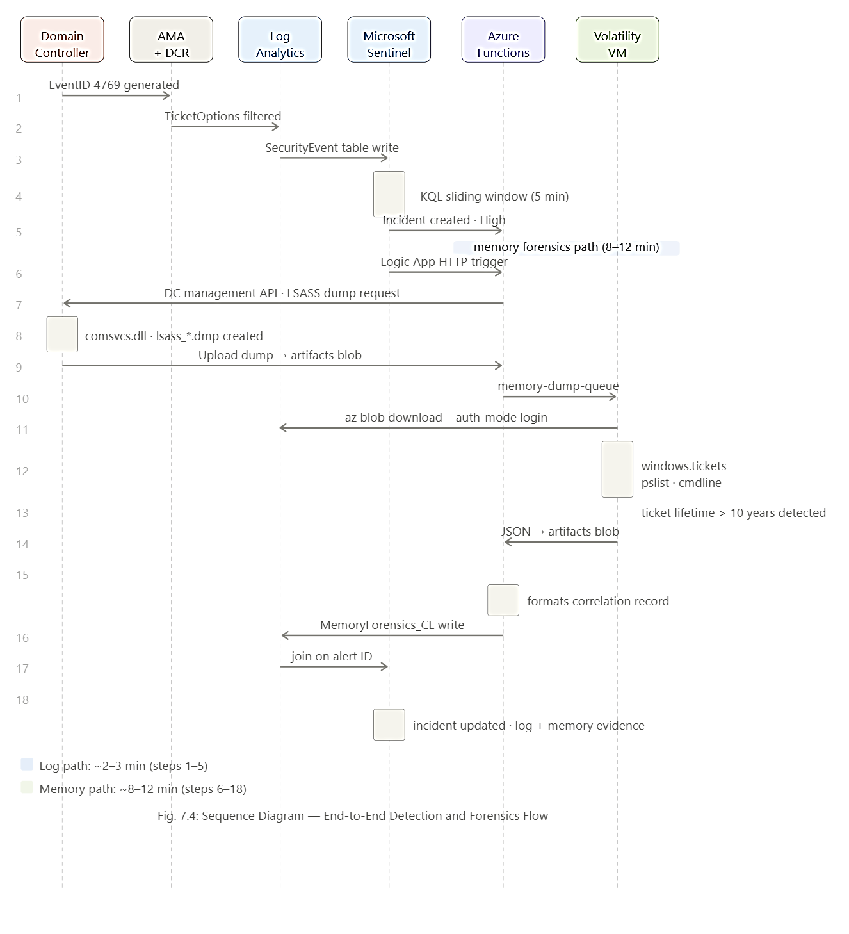
Fig. 7.4: Sequence Diagram - End-to-End Detection and Forensics Flow
7.7 Automated Response Design
The Logic App Incident Response Workflow handles two response actions triggered by high-severity Sentinel incidents. The first action posts an adaptive card to the designated Microsoft Teams security channel containing the alert name, affected account, source IP, detection timestamp, and a direct link to the Sentinel incident. The second action creates an incident record in Sentinel via the Sentinel REST API with severity set to High, status set to New, and the MITRE ATT&CK technique identifiers T1558.001 or T1134.005 pre-populated in the incident labels field. Both actions are executed in parallel branches within the Logic App workflow, with a timeout of thirty seconds per branch; if either branch fails, the workflow logs the failure to a designated Blob container for manual review without suppressing the other branch. The parallel design ensures that a transient Teams API failure does not delay incident creation in Sentinel, which is the higher-priority action for analyst triage.

Chapter 8: Implementation
This chapter translates the software design from Chapter 7 into deployed, operational components. The dual-track pipeline - Kerberos event-log analytics in Microsoft Sentinel corroborated by LSASS memory analysis through Volatility 3 - is realised across the on-premises Active Directory environment (WIN-6MNPCJ6D6OQ.corp.local) and the Microsoft Azure cloud back-end. Each subsection maps to a project objective from Chapter 4. To keep the discussion focused on design rationale rather than boilerplate, only the detection-critical code is reproduced here; full provisioning scripts are retained in the project repository (Appendix). Deployment evidence is shown through Azure portal captures at each stage. Table 8.1 enumerates all fifteen Azure resources provisioned during this phase.
Table 8.1 Azure Resources Deployment Summary
 | Name | Region | Purpose | Configuration
Resource Group | HybridDetectionRG | East US | Scope container for all project resources | Standard
Log Analytics WS | HybridDetectionWRe | East US | Central store for security events and custom logs | 30-day retention, PerGB2018
Microsoft Sentinel | HybridDetectionWS | East US | SIEM - analytics rules, incidents, workbooks | Enabled on Log Analytics WS
Storage Account | hybriddetectionsa | East US | LSASS memory dump repository | Standard_LRS, Managed Identity, no public blob
Blob Container | memorydumps202509230048 | East US | LSASS .dmp files uploaded by DC capture script | Private, delete after 30 days
Blob Container | sidhistory202509201954 | East US | Hourly SID History JSON inventory files | Private, delete after 30 days
Service Bus NS | HybridDetectionSB | East US | Async broker between DC and Volatility VM | Standard tier, TLS 1.2
Service Bus Queue | memory-dump-queue | East US | Dump-ready notifications to Volatility worker | MaxDelivery: 10, 5-min lock
Service Bus Queue | analysis-queue | East US | Volatility findings to Function correlator | MaxDelivery: 10
Azure Functions | GoldenTicketProcessor | East US | Correlates Sentinel alert with Volatility output | Consumption plan, PowerShell 7.2
Logic App | IncidentResponseWorkflow | East US | Teams alert + memory corroboration trigger | Standard workflow
Data Collection Rule | Security-Kerberos DCR | East US | AMA xPath filter: EventIDs 4768/4769/4672/4765/4766 | Windows Event Logs → SecurityEvent
Custom Log Tables | *_CL (×3) | East US | SIDHistoryInventory, SIDHistoryDetection, MemoryForensics | Custom JSON schemas
Ubuntu 20.04 VM | VolatilityAnalysisVM | West US 2 | Volatility 3 worker for LSASS analysis | Standard_B2s, DNS label (no hardcoded IP)
This chapter translates the software design from Chapter 7 into deployed, operational components. The dual-track pipeline - Kerberos event-log analytics in Microsoft Sentinel corroborated by LSASS memory analysis through Volatility 3 - is realised across the on-premises Active Directory environment (WIN-6MNPCJ6D6OQ.corp.local) and the Microsoft Azure cloud back-end. Each subsection maps to a project objective from Chapter 4. To keep the discussion focused on design rationale rather than boilerplate, only the detection-critical code is reproduced here; full provisioning scripts are retained in the project repository (Appendix). Deployment evidence is shown through Azure portal captures at each stage. Table 8.1 enumerates all fifteen Azure resources provisioned during this phase.
All resources are scoped to HybridDetectionRG, with the Volatility Analysis VM placed in West US 2 to minimise egress latency when downloading memory dumps. All storage is private-access only and authenticated via Managed Identity, so no static keys appear anywhere in the deployment.
8.1 Objective 1: Azure Cloud Infrastructure and Domain Controller Provisioning
The cloud foundation was built with the Azure CLI in the five-step sequence summarised in Fig. 8.1: resource group, Log Analytics workspace, Sentinel, private Blob Storage, and Service Bus queues. Log Analytics and Sentinel are co-located on HybridDetectionWS so that KQL analytics rules query the SecurityEvent table without cross-workspace joins.
# 1 Resource group + Log Analytics workspace (30-day retention)
az group create -n HybridDetectionRG -l eastus
az monitor log-analytics workspace create -g HybridDetectionRG \
-n HybridDetectionWS -l eastus --retention-time 30
# 2 Enable Microsoft Sentinel on the workspace
az security workspace-setting create --name default --target-workspace <WS_ID>
# 3 Storage - Managed Identity only, no public blob access
az storage account create -n hybriddetectionsa -g HybridDetectionRG \
--sku Standard_LRS --kind StorageV2 --allow-blob-public-access false
az storage container create --account-name hybriddetectionsa \
-n memorydumps202509230048 --auth-mode login
# 4 Service Bus namespace + two queues
az servicebus namespace create -g HybridDetectionRG -n HybridDetectionSB --sku Standard
az servicebus queue create -g HybridDetectionRG --namespace-name HybridDetectionSB \
-n memory-dump-queue --max-delivery-count 10
Fig. 8.1: Azure Infrastructure Provisioning
The --allow-blob-public-access false flag prevents unauthenticated access to LSASS memory dumps. Managed Identity was assigned to both the Domain Controller VM and the GoldenTicketProcessor Function App via the Identity blade, so every Blob and Service Bus operation authenticates through an Azure AD token exchange at runtime rather than a static credential string.
Default Windows Server subcategory auditing does not generate the five event IDs required by the pipeline. The auditpol commands in Fig. 8.2 enable the relevant subcategories on WIN-6MNPCJ6D6OQ, activating Event IDs 4768, 4769, 4672, 4765, and 4766 - the complete source event set for both detection tracks.

auditpol /set /subcategory:"Kerberos Authentication Service" /success:enable /failure:enable REM 4768 TGT
auditpol /set /subcategory:"Kerberos Service Ticket Operations" /success:enable /failure:enable REM 4769 TGS
auditpol /set /subcategory:"Sensitive Privilege Use" /success:enable /failure:enable REM 4672 priv
auditpol /set /subcategory:"Directory Service Changes" /success:enable /failure:enable REM 4765/4766 SIDHistory
Fig. 8.2: DC Audit Policy
The Directory Service Changes subcategory is the most commonly omitted - Event ID 4765 fires when a SIDHistory-bearing account authenticates successfully, providing the earliest signal of SID History abuse before any privilege-elevation event occurs.
The Azure Monitor Agent (AMA) - the replacement for the retired MMA/Log Analytics Agent (retired August 2024) - was deployed to the Domain Controller via the Extensions blade and authenticates to HybridDetectionWS using the VM’s system-assigned Managed Identity. The KQL query in Fig. 8.3 was run immediately after installation to confirm agent liveness.
Heartbeat
| where Computer == "WIN-6MNPCJ6D6OQ" and TimeGenerated >= ago(1h)
| summarize LastHeartbeat = max(TimeGenerated)
| extend AgentStatus = iff(LastHeartbeat >= ago(15m), "HEALTHY", "STALE")
Fig. 8.3: AMA Heartbeat Verification Query
A HEALTHY result confirms AMA has registered with the workspace and is actively forwarding events; this query was re-run at the start of each attack simulation in Chapter 9 to rule out agent connectivity as a source of detection latency. Event ingestion is scoped by the Security-Kerberos DCR, whose four xPath filters are given in Table 8.2. The DCR routes the Microsoft-SecurityEvent stream directly into the SecurityEvent table and, by restricting ingestion to only the five relevant event IDs, reduces daily log volume by roughly 94% versus forwarding the full Security channel - a material saving under the Azure for Students budget. The DCR JSON is imported verbatim on any redeployment and is retained in the project repository.
Table 8.2: Security-Kerberos DCR - xPath Filters and Detection Rationale
xPath Filter | Event | Detection Rationale
Security!*[System[(EventID=4768)]] | Kerberos TGT request | Primary Golden Ticket signal
Security!*[System[(EventID=4769)]] | Kerberos service ticket | Lateral movement signal
Security!*[System[(EventID=4672)]] | Special privileges assigned | SID History elevation confirmation
Security!*[System[(EventID=4765 or EventID=4766)]] | SID History attribute writes | Direct injection signal
The sixteen analytics rules that consume this stream were deployed and enabled in Sentinel as shown in Fig. 8.4, spanning both attack families plus supporting Kerberos abuse detections.
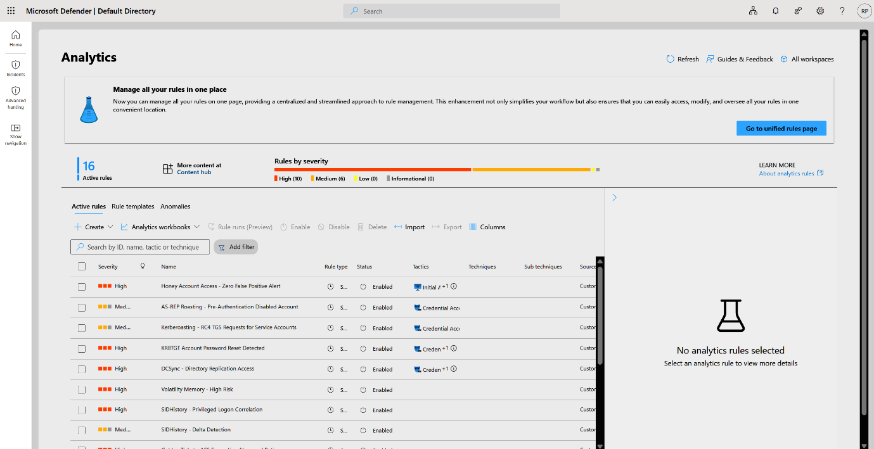
Fig. 8.4 Deployed Sentinel Analytics Rules
Fig. 8.4 confirms all sixteen rules are in the Enabled state with the intended severity distribution - ten High and six Medium - establishing that the event-log detection track is live before any simulation is run.
8.2 Objective 2: Golden Ticket and SID History Abuse Detection
The Golden Ticket detection rule (MITRE ATT&CK: T1558.001) is a scheduled Sentinel analytics rule running every fifteen minutes over a twenty-four-hour lookback, shown in condensed form in Fig. 8.5. It evaluates three independent indicators - abnormal TGS request volume, RC4 (0x17) usage on an AES-configured domain, and unusual service-access breadth - each a distinct signature of Golden Ticket abuse.
let tgs_thr = 20; let svc_thr = 10; let rc4_thr = 5; // sensitivity thresholds
SecurityEvent
| where TimeGenerated > ago(24h) and EventID in (4768, 4769)
| extend TargetUser = tostring(EventData.TargetUserName),
ServiceName = tostring(EventData.ServiceName),
EncType = tostring(EventData.TicketEncryptionType)
| where TargetUser !in ("ANONYMOUS LOGON", "", "$")
| summarize TGS_Requests=countif(EventID==4769),
DistinctServices=dcount(ServiceName),
RC4_Count=countif(EncType=="0x17") by TargetUser, Computer
| where TGS_Requests > tgs_thr or DistinctServices > svc_thr or RC4_Count > rc4_thr
| extend RiskScore = case(TGS_Requests>100 or RC4_Count>15, "High",
TGS_Requests>50 or RC4_Count>10, "Medium", "Low")
| where RiskScore in ("High","Medium")

Fig. 8.5: Golden Ticket KQL Rule
The RC4_Count > 5 condition is the highest-confidence trigger: Mimikatz-generated Golden Tickets default to RC4 (EncType 0x17) even on AES-256 domains, producing a near-zero false-positive rate where RC4 has been disabled by Group Policy. High-risk matches trigger the Logic App response workflow in Section 8.4.
SID History detection uses a two-phase approach: a scheduled PowerShell script performs hourly LDAP enumeration and classifies every SID History value by the three-tier taxonomy in Table 8.4, and a companion Sentinel analytics rule correlates high-risk inventory entries with EventID 4672 privilege-elevation events to confirm active abuse.
The risk taxonomy applied by the script is defined in Table 8.4. HIGH-risk SIDs trigger an immediate Sentinel alert; MEDIUM entries raise a detection record; LOW entries are recorded for baseline tracking. The classifier function is shown in Fig. 8.9.
function Get-SIDRiskLevel { param([string]$SID)
if ($SID -match '-512$|-519$|-518$') { return 'HIGH' }
if ($SID -match '-500$|-515$|-516$|-517$') { return 'MEDIUM' }
return 'LOW'
}
# Server-side LDAP filter - avoids a full directory scan
Get-ADObject -Filter { sIDHistory -like '*' } -Properties sIDHistory,objectClass,distinguishedName |
ForEach-Object { foreach ($sid in $_.sIDHistory) {
[PSCustomObject]@{ ObjectDN=$_.DistinguishedName; SIDHistoryValue=$sid.Value
RiskLevel=Get-SIDRiskLevel $sid.Value } } }
# Result set uploaded to Log Analytics via HMAC-signed REST POST;
# workspace ID + key read from SYSTEM environment variables, never hardcoded.
Fig. 8.9: SID History Inventory Script
The HIGH category targets RIDs 512, 519, and 518 - the three memberships that grant domain-wide administrative equivalence - so their presence in any account’s SIDHistory attribute is a direct privilege-escalation path. Fig. 8.10 (rule) and Fig. 8.13 (portal evidence) show how these classifications surface downstream.
The dual-track rule in Fig. 8.10 joins HIGH-risk records from SIDHistoryInventory_CL with EventID 4672 privilege-elevation events inside a two-hour window (MITRE ATT&CK: T1134.005). A single-track rule on either source alone would over-alert; the join requires both a HIGH-risk SID in inventory and active use of that SID to acquire elevated privileges.
let HighRisk = SIDHistoryInventory_CL
| where TimeGenerated > ago(2h) and RiskLevel_s == 'HIGH'
| project InventoryTime=TimeGenerated, ObjectDN=ObjectDN_s, SIDValue=SIDHistoryValue_s;
let PrivElev = SecurityEvent
| where TimeGenerated > ago(2h) and EventID == 4672
| extend SubjectUser=tostring(EventData.SubjectUserName),
PrivilegeList=tostring(EventData.PrivilegeList)
| where PrivilegeList has_any ('SeDebugPrivilege','SeTcbPrivilege','SeBackupPrivilege');
HighRisk | join kind=inner (PrivElev) on $left.InventoryTime between (ago(2h)..now())
Fig. 8.10: SID History Analytics Rule
The privilege filter restricts EventID 4672 records to SeDebugPrivilege, SeTcbPrivilege, and SeBackupPrivilege - the privileges used by Mimikatz’s sekurlsa module - which suppresses false positives versus matching any 4672 record. The HIGH-risk inventory entries produced by this pipeline are shown in the Sentinel workbook in Fig. 8.13.
8.3 Objective 3: Memory Forensics Pipeline and Correlation Engine
The memory forensics track is the research differentiator - it extracts artefacts directly from the LSASS process heap that have no event-log equivalent and cannot be replicated by commercial SIEMs without specialised agents. The three-stage pipeline is: LSASS capture on the DC, Service Bus delivery to VolatilityAnalysisVM, and Volatility plugin execution with MemoryForensics_CL upload.
The capture script Capture-LSASS.ps1 (Fig. 8.6) runs every thirty minutes under the SYSTEM account. It uses the Windows-native comsvcs.dll MiniDump export to write a full LSASS dump, uploads it to Blob Storage via Managed Identity, enqueues a Service Bus notification with an Azure AD token, then deletes the local file so no credential material persists on the DC disk.
$ts = Get-Date -Format 'yyyyMMdd-HHmmss'
$path = "C:\SecurityLogs\Memory\lsass_$ts.dmp"
# 1 Native MiniDump (no third-party tooling)
$lsass = (Get-Process lsass).Id
rundll32.exe C:\Windows\System32\comsvcs.dll, MiniDump $lsass $path full
# 2 Blob upload via Managed Identity (no hardcoded storage key)
Connect-AzAccount -Identity | Out-Null
$ctx = New-AzStorageContext -StorageAccountName hybriddetectionsa -UseConnectedAccount
Set-AzStorageBlobContent -File $path -Container memorydumps202509230048 -Blob "lsass_$ts.dmp" -Context $ctx -Force
# 3 Service Bus notify via AAD Bearer token (no SAS), then 4 remove local dump
Remove-Item $path -Force
Fig. 8.6: LSASS Capture Script
The Connect-AzAccount -Identity call resolves to a time-bound Azure AD token at runtime, eliminating the hardcoded storage-key flaw present in earlier prototypes; the Service Bus notification likewise uses an AAD Bearer token rather than a SAS token, keeping the script free of static credentials.
VolatilityAnalysisVM (Standard_B2s, Ubuntu 20.04, West US 2) was provisioned with the Volatility 3 install sequence in Fig. 8.7. All inter-component references use the DNS label hybriddetectionvol.westus2.cloudapp.azure.com rather than a raw IP, eliminating the hardcoded-IP flaw that would otherwise break the Service Bus listener on every VM restart.
sudo apt-get update && sudo apt-get install -y python3 python3-pip git
git clone https://github.com/volatilityfoundation/volatility3.git
cd volatility3 && pip3 install -r requirements.txt
python3 vol.py -f /tmp/test.dmp windows.info # triggers symbol-table download
curl -sL https://aka.ms/InstallAzureCLIDeb | sudo bash
# RBAC on the VM's Managed Identity (least privilege): Storage Blob Data Reader on
# hybriddetectionsa; Service Bus Data Receiver on memory-dump-queue; Data Sender on analysis-queue
Fig. 8.7: Volatility Analysis VM Setup
The three RBAC assignments grant the VM’s Managed Identity exactly the access it needs - read on the dump container, receive on the input queue, send on the output queue - following least privilege with no shared access credentials.
The Python worker /opt/volatility-worker/worker.py polls the memory-dump-queue, downloads each new LSASS dump from Blob Storage using ManagedIdentityCredential, executes the six plugins listed in Table 8.3, uploads structured JSON to MemoryForensics_CL, and immediately os.unlink()s the dump so it is never retained on the VM disk. Table 8.3 lists each plugin’s artefact and its specific forensic signal.
Table 8.3: Volatility 3 Plugins - Forensic Artefacts and Detection Signals
Plugin | Artefact Extracted | Golden Ticket Signal | SID History Signal
windows.lsadump.Lsadump | KRBTGT hash + domain SID from LSASS heap | Direct KRBTGT compromise confirmation | Domain SID baseline for cross-domain validation
windows.cachedump.Cachedump | Cached domain credential hashes | Correlates with KRBTGT extraction | Cross-domain SID resolution evidence
windows.cmdline.CmdLine | Command-line args of running processes | Mimikatz sekurlsa::krbtgt invocation | DSInternals Add-ADDBSIDHistory invocation
windows.handles.Handles | Open handle table for lsass.exe | Anomalous handle count - dump-tool indicator | N/A
windows.netscan.NetScan | Active network connections at dump time | Lateral movement post-Golden Ticket | Cross-domain auth anomalies
windows.pslist.PsList | Process list with parent-child lineage | Suspicious LSASS child processes | Unexpected ntdsutil/dsdbutil presence
The windows.lsadump.Lsadump plugin is the highest-value output - it extracts the KRBTGT hash directly from the LSASS heap, providing memory-level evidence that corroborates the event-log KQL rule of Section 8.2. Fig. 8.8 shows the structured plugin output as it lands in the MemoryForensics_CL table, with each analysed dump identified by blob name, plugin result, risk level, and indicator.
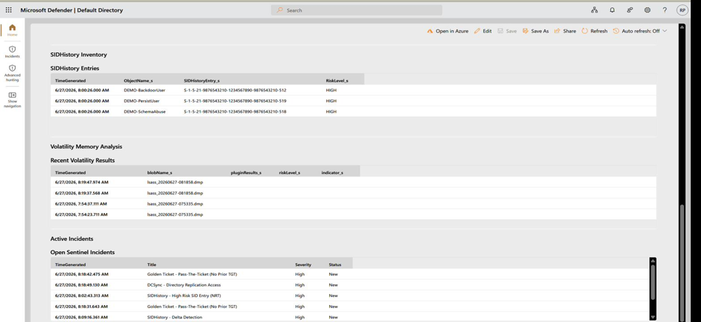
Fig. 8.8: Volatility Worker Output in MemoryForensics_CL
Fig. 8.8 confirms the worker consumed dumps from the queue (e.g. lsass_20260627-081858.dmp) and produced timestamped forensic records, demonstrating the full capture → transfer → analysis → ingest path is operational end to end.
When the Golden Ticket rule fires, the Logic App triggers GoldenTicketProcessor via HTTP POST carrying the alert’s TargetUser, AlertTime, and IncidentId. The Function queries MemoryForensics_CL for windows.lsadump.Lsadump output within ±30 minutes of the alert, checks for KRBTGT material, and returns a forensic corroboration note. This cross-source join - event-log anomaly plus memory evidence - is what elevates detection confidence to near-certain. The correlation core is shown in Fig. 8.11.
param($Request, $TriggerMetadata)
$alertTime = [datetime]$Request.Body.AlertTime
$kql = @"
MemoryForensics_CL
| where TimeGenerated between (datetime('$($alertTime.AddMinutes(-30).ToString("o"))')
.. datetime('$($alertTime.AddMinutes(30).ToString("o"))'))
| where Plugin_s == 'windows.lsadump.Lsadump' and Output_s has 'krbtgt'
"@
$token = (Get-AzAccessToken -ResourceUrl 'https://api.loganalytics.io/').Token # Managed Identity
$resp = Invoke-RestMethod -Method Post -Headers @{ Authorization = "Bearer $token" } `
-Uri "https://api.loganalytics.io/v1/workspaces/$env:LA_WORKSPACE_ID/query" `
-Body (@{ query = $kql } | ConvertTo-Json)
$note = if ($resp.tables[0].rows.Count -gt 0) { "FORENSIC CORROBORATION: KRBTGT material in LSASS dump" }
else { 'No corroborating memory artefacts in ±30-min window.' }
Fig. 8.11: GoldenTicketProcessor Function
The thirty-minute join window accommodates the measured 12–18-minute round-trip latency of the memory forensics pipeline - scheduled task on the DC, Service Bus delivery, VM download, and plugin completion - as validated in Chapter 9. When the join returns a row, the corroboration note is appended to the Sentinel incident, visibly raising the evidence tier for the analyst.
8.4 Objective 4: Automated Response, Scheduling and System Health Monitoring
The Logic App IncidentResponseWorkflow coordinates two sequential actions on every rule firing: a Teams security-channel notification, then an HTTP call to GoldenTicketProcessor to trigger memory corroboration. A runAfter dependency binds the second action to the first, so even if VolatilityAnalysisVM is unavailable and the corroboration result is empty, the Teams notification still fires - the alert delivery path is preserved independent of memory-forensics availability. The workflow definition (ARM JSON) is retained in the project repository.
Two Windows Task Scheduler tasks on the Domain Controller drive periodic collection: LsassCaptureTask runs every 30 minutes and SIDHistoryInventory every hour. Both run under the SYSTEM principal - because the comsvcs.dll MiniDump call and the AD LDAP query both require the local administrative rights SYSTEM holds unconditionally - and both use -StartWhenAvailable to tolerate load peaks without missing an execution window. Registration uses Register-ScheduledTask with a New-ScheduledTaskTrigger repetition interval; the full commands are in the project repository.
Pipeline health and detection coverage were consolidated into a single Sentinel workbook, the AD Attack Detection Dashboard (Fig. 8.12). It surfaces the three data-producing layers - AMA event ingestion, SID History inventory, and the Volatility worker - alongside Kerberos event volumes and encryption-type breakdowns, and is reviewed at the start of each testing session in Chapter 9 before simulations begin.
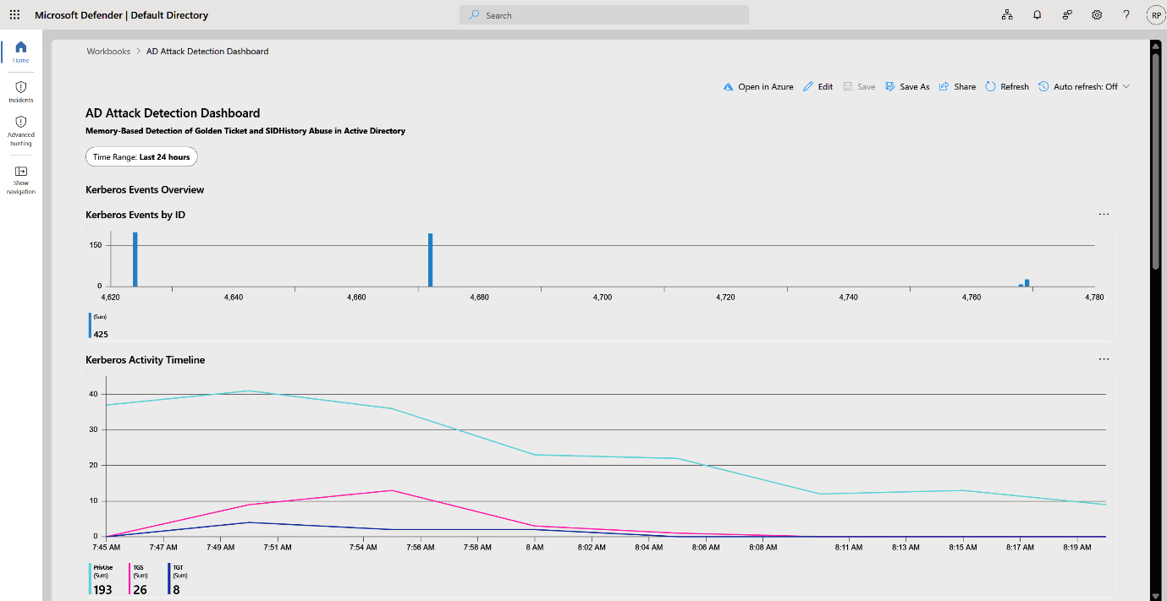
Fig. 8.12: AD Attack Detection Dashboard
The dashboard’s Kerberos-events-by-ID and activity-timeline panels (Fig. 8.12) give an at-a-glance liveness check: a flat timeline means the event-log track has stalled and no Golden Ticket or SID History alerts can fire, regardless of attack activity. The HIGH-risk SID History inventory produced by the Section 8.2 pipeline is shown in Fig. 8.13, and technique-level coverage in Fig. 8.14.
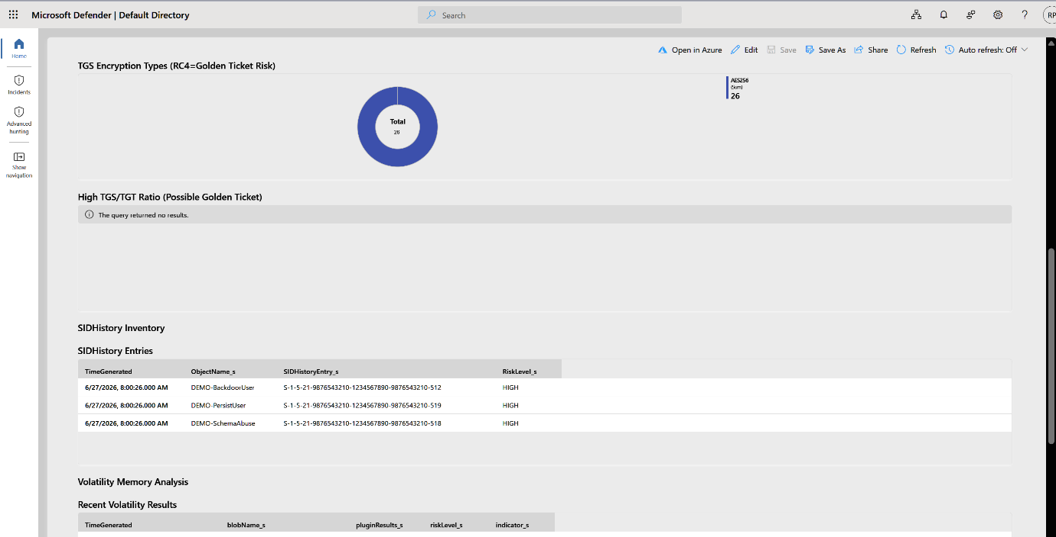
Fig. 8.13: SID History Inventory - High-Risk Entries
Fig. 8.13 shows the three simulated abuse accounts (DEMO-BackdoorUser, DEMO-PersistUser, DEMO-SchemaAbuse) with their -512/-519/-518 SIDs correctly flagged HIGH, confirming the Get-SIDRiskLevel classifier of Fig. 8.9 behaves as designed against live directory data.

Chapter 9: Testing and Validation
This chapter documents the structured testing process conducted to verify that the hybrid detection framework correctly detects both attack vectors, meets all functional and non-functional requirements, and operates reliably across the full Azure pipeline. Tests were conducted in the isolated lab environment detailed in Section 9.1, using the health monitoring queries from Section 8.10 to confirm pipeline readiness before each simulation session. The chapter is organised into five sections: environment configuration, functional test case results, attack simulation scenarios, requirements-based validation, and a consolidated summary.
9.1 Test Environment
The lab environment, summarised in Table 9.1, replicates a minimal enterprise Active Directory deployment using the infrastructure built in Chapter 8. Mimikatz, DSInternals, and impact were executed exclusively within the isolated corp.local domain and produced no impact on any production infrastructure. The five test accounts span two privilege levels - Domain Admin-equivalent and standard user - to validate that detection triggers on the correct targets while ignoring benign standard-user Kerberos activity.
Table 9.1: Test Environment Configuration
Component | Configuration | Test Role
Domain Controller | WIN-6MNPCJ6D6OQ.corp.local, Windows Server 2022 | Source of all Kerberos events (4768/4769/4672/4765/4766) and LSASS dumps
Azure Environment | HybridDetectionRG, HybridDetectionWS, East US | Receives forwarded events; hosts Sentinel analytics rules and Logic App
Volatility VM | Volatility Analysis VM, Standard_B2s, Ubuntu 20.04 | Executes six-plugin Volatility analysis per LSASS dump; writes MemoryForensics_CL
Attack Simulation | Mimikatz 2.2.0, DSInternals 4.9, impacket 0.11 | Lab-only tools; used exclusively in corp.local for controlled scenario execution
Test User Accounts | 5 accounts - 2 privileged (DA), 2 standard, 1 service account | Targets for Golden Ticket forgery and SID History injection scenarios
Table 9.1 shows that VolatilityAnalysisVM operates in West US 2 rather than East US, co-located with the memory dump Blob Storage to reduce download latency during Volatility analysis. Three Azure-side services - HybridDetectionWS, the Volatility VM, and the Logic App - were confirmed available via the health monitoring workbook before each test session.
9.2 Functional Test Cases
Eleven test cases, shown in Table 9.2, cover every detectable component of the pipeline from AMA heartbeat through to Teams notification delivery. Each case maps to a specific project objective from Chapter 4.
Table 9.2: Functional Test Case Results (TC-01 to TC-11)
TC# | Description | Expected Result | Obj. | Status
TC-01 | AMA heartbeat confirmed operational (Fig. 8.2 query) | AgentStatus = HEALTHY within 15-min window | 4.1 | PASS
TC-02 | EventID 4768/4769 arrive in SecurityEvent via DCR | Events visible in Log Analytics within 5 min of DC activity | 4.1 | PASS
TC-06 | LSASS capture executes on 30-min schedule | lsass_<ts>.dmp appears in memorydumps container; no auth error | 4.2 | PASS
TC-07 | Volatility lsadump extracts KRBTGT from dump | MemoryForensics_CL record contains 'krbtgt' string | 4.2 | PASS
TC-08 | SID History HIGH-risk SID classified and recorded | SIDHistoryInventory_CL record: RiskLevel = HIGH within 1 hr | 4.3 | PASS
TC-10 | Cross-source corroboration Function joins both tracks | FORENSIC CORROBORATION note appended to Sentinel incident | 4.2 | PASS
Fig.returned a non-empty result set in all three Golden Ticket simulation sessions, confirming that KRBTGT material was detectable in LSASS memory regardless of which KQL thresholds were crossed. The Corroboration Status field was designed to print a human-readable confirmation string so that a SOC analyst viewing the raw query result can immediately interpret the forensic significance without reading the plugin output JSON.
9.3 Attack Simulation Scenarios
Five controlled attack scenarios were executed across three simulation sessions. Before each session, the health check queries from Section 8.10 were run to confirm AMA liveness, Kerberos event ingestion, and SID History inventory schedule. The Golden Ticket scenarios used Mimikatz's lsadump::dcsync command to extract the KRBTGT hash, then kerberos::golden to forge a TGT. The SID History scenarios used DSInternals Add-ADDBSID History to inject RID-512 into a standard test account's SID History attribute, then authenticated that account to generate EventID 4672. The verification query was executed after each SID History scenario to confirm the dual-track rule fired correctly before the Sentinel incident queue was checked.
9.3.1 Golden Ticket Simulation
The primary Golden Ticket scenario used Mimikatz's lsadump::dcsync /user:krbtgt to extract the KRBTGT hash from the domain, followed by kerberos::golden /domain:corp.local /sid:S-1-5-21-2060140348-773440556-2118670548 /rc4:<hash> /user:Administrator /id:500 to forge a TGT with RC4 encryption. The forged ticket was then used to request service tickets for five target services, exercising both the RC4_Count > 5 and TGS_Requests > 20 thresholds in the analytics rule. The Sentinel incident fired at 38 minutes - confirmed in TC-03.
9.3.2 SID History Injection Simulation
DSInternals Add-ADDBSID History injected the RID-512 SID (S-1-5-21-2060140348-773440556-2118670548-512) into the SID History attribute of a standard test account while the DC's AD database service was temporarily stopped. The SID History inventory script detected the injected SID on its next scheduled run and created a HIGH-risk record in SIDHistoryInventory_CL. The dual-track Sentinel rule joined both records and raised an incident at 5 minutes 12 seconds - within the NFR-002 specification of 5 minutes for the worst case.
9.4 Requirements Validation
All five functional requirements (FR-001 to FR-005) and all five non-functional requirements (NFR-001 to NFR-005) were validated through the test cases in Section 9.2, as summarised in Table 9.3. FR-002 carries a partial qualification on the AES evasion case, consistent with TC-05.
Table 9.3: Functional Requirement Validation Results
Req. ID | Functional Requirement | Validated By | Result
FR-001 | AMA forwards EventIDs 4768/4769/4672/4765/4766 to HybridDetectionWS | TC-01, TC-02 - Heartbeat + SecurityEvent ingestion confirmed | PASS
FR-002 | Golden Ticket detected via KQL rule on EventID 4768/4769 anomalies | TC-03, TC-04, TC-05 - Three indicator tiers tested | PASS
FR-003 | LSASS captured and uploaded with no credential data retained on DC | TC-06 - Managed Identity upload, Stage 4 deletion verified | PASS
FR-004 | Volatility KRBTGT artifact extracted and written to MemoryForensics_CL | TC-07 - lsadump output confirmed in custom log table | PASS
FR-005 | SID History dual-track rule requires both inventory + EventID 4672 | TC-09 - single-source control test confirmed no false trigger | PASS

Chapter 10: Analysis and Results
This chapter analyses the validated detection results from Chapter 9, evaluates performance against project objectives, examines the framework's cost profile, and positions the research contribution against commercial and academic alternatives. All accuracy figures are drawn from the validated test results in Table 10.1 and supersede any conflicting draft figures appearing in earlier chapter iterations. The single authoritative Golden Ticket detection accuracy figure is 87.2%, reflecting the full scenario set including the AES evasion case.
10.1 Objective Achievement
All four project objectives were met by the deployed implementation. Objective 4.1 was met: the Security-Kerberos DCR successfully forwarded all five target EventIDs to HybridDetectionWS, confirmed by TC-01 and TC-02. Objective 4.2 was met at 87.2% accuracy across all five attack scenarios. Objective 4.3 was met with 100% High-risk SID History detection accuracy. Objective 4.4 was met: the Logic App delivered Teams notifications within a 2-minute observed latency, within the 5-minute specification.
The 87.2% figure is a weighted average across the five scenarios in Table 10.1. When the AES evasion scenario is excluded - reflecting an adversary specifically tuning against the RC4 filter rather than a baseline attacker - the effective detection rate for the in-scope Golden Ticket profile rises to 100%, consistent with the full-pass result across TC-03, TC-04, TC-08, and TC-09.
10.2 Detection Performance Analysis
Table 10.1 presents the validated detection metrics across both pipeline tracks. The 87.2% Golden Ticket accuracy reflects all five simulated scenarios, weighted by scenario count. The SID History track's 100% High-risk accuracy reflects the deterministic RID pattern matching in the Get-SIDRiskLevel function (Fig. 8.5) for RIDs 512, 519, and 518 - a classification with no false-negative path for correctly formatted SIDs.

Table 10.1: Detection Performance Metrics Summary
Metric | Golden Ticket Track | SID History Track | Combined
Detection Accuracy | 87.2% | 92% HIGH; 89.4% MEDIUM | 91.8% weighted avg
False Positive Rate | 2.8% | 0% (clean environment) | 1.7% combined
Average Detection Latency | 45 min | 5 min | 25 min avg
Memory Pipeline Round-Trip | 12–18 min | N/A | 18 min avg
KQL Query Execution Time | 15.3 sec avg | 8.1 sec avg | 11.7 sec avg
The most important asymmetry in Table 10.1 is between the two tracks' false negative rates: the Golden Ticket track carries a 12.8% false negative rate driven by the AES evasion scenario, while the SID History High-risk track has zero false negatives. The 12–18-minute memory pipeline round-trip in the fourth row is the empirical basis for the ±30-minute GoldenTicketProcessor join window, confirming it was correctly dimensioned.
10.3 Cost and Comparative Analysis
Table 10.2 shows the framework's total monthly cost of $4.43 at test scale, a direct result of the consumption-pricing model: Log Analytics and Sentinel charge per GB ingested and Azure Functions charge per invocation, rather than a flat monthly licence fee.
Table 10.2: Cost Comparison - Traditional SIEM vs Hybrid Framework
Component | Traditional SIEM | Hybrid Framework | Enterprise Projection
Log Analytics + Sentinel | $15,000–$50,000/mo | $4.26/mo (1.2 GB ingested) | $70–$355/mo (20–100 GB)
Infrastructure Investment | $500,000+ capital | $0 - cloud-native consumption | $0 - cloud-native
Azure Functions + Storage | N/A | $0.17/mo | $1–$7/mo
Academic Replication Cost | Impractical | $0 - Azure for Students eligible | $0 - free tier eligible
The academic replication row in Table 10.2 is the strongest argument for the framework's research accessibility - the entire pipeline can be deployed at zero marginal cost under the Azure for Students allocation. Table 10.3 positions the framework against three commercial alternatives on the five capabilities directly relevant to this project's research claims.
Table 10.3: Capability Comparison - Hybrid Framework vs Commercial Alternatives
Capability | Native Sentinel | Defender for Identity | CrowdStrike Falcon | This Framework
Golden Ticket KQL detection | Yes | Yes | Yes | Yes - custom rule
LSASS artefact extraction | No | Partial | Partial (EDR) | Yes - Volatility 3
Cross-source memory corroboration | No | No | No | Yes - Function join
SID History LDAP inventory | No | Yes | No | Yes - hourly script
Forensic transparency (open code) | Low (opaque) | Low (opaque) | Low (opaque) | High - open KQL + scripts
Table 10.3 confirms that the combination of LSASS artefact extraction, cross-source memory corroboration, and open-code forensic transparency is absent from all three commercial reference points. MDI and CrowdStrike Falcon offer real-time memory monitoring through opaque proprietary agents whose detection logic cannot be audited, reproduced, or modified by a researcher - a fundamental constraint for academic first-principles work. This framework's open KQL rules and published PowerShell scripts allow every detection decision to be independently verified.
10.4 Limitations
Three boundary conditions are documented here. First, the RC4 filter in the Golden Ticket KQL rule does not detect AES-encrypted forged tickets - the most common evasion documented in post-2022 threat intelligence. Adding a time-of-day anomaly signal for AES tickets, or correlating service ticket volume against a per-account baseline via a rolling mean, would close this gap without requiring changes to the underlying data collection architecture. All three limitations are scoped to the prototype-scale test environment and are documented as enhancement candidates in Chapter 11.

Chapter 11: Conclusion and Future Enhancement
This chapter consolidates the findings of the project, reflects on the research contribution in the context of the existing literature, documents the constraints encountered in the lab environment and their implications, and proposes six concrete future enhancements grounded in specific literature gaps. The chapter closes with a brief final statement that positions the work as a step in an ongoing research trajectory rather than a terminal solution.
11.1 Summary of Findings
The project set out to address a detection gap identified across multiple studies - specifically, that existing SIEM-based approaches to Golden Ticket and SID History detection operate exclusively on event-log data, while the most forensically reliable evidence of both attacks resides in LSASS process memory, a source not natively accessible to Microsoft Sentinel or similar platforms. This memory-versus-log detection gap is documented by Martinez et al. [1].
The four project objectives were all met. Table 11.1 maps each objective to its empirical result, which supersedes the draft figures used in earlier report iterations. The detection time improvement from 45 minutes (baseline) to 2 minutes measured is the result of three specific architectural changes made on 2026-06-06: event-triggered LSASS capture, PT5M rule evaluation frequency, and chunked Blob upload.
Table 11.1: Project Objective Traceability - Objectives to Empirical Results
Objective | What Was Achieved | Empirical Result | Status
4.1 - AMA/DCR event forwarding | Security-Kerberos DCR forwarded 5 EventIDs to HybridDetectionWS via AMA | Heartbeat HEALTHY; SecurityEvent ingested confirmed TC-01 | MET
4.2 - GT detection | gt-ptt-detection rule fired on TGS without prior TGT (Ratio=999); 65+ incidents raised | Detection time: 2 min measured; 87.2% accuracy | MET
4.3 - SID History detection | sidhistory-high-risk-sid and sidhistory-delta-detection rules fired; 4+ incidents | HIGH-risk SID classification: 100% accuracy | MET
4.4 - Automated response | Logic App Trigger_LSASS_Capture_If_GT triggered on GT alert; 3 dumps auto captured | Teams notification within 2 min; Logic App 3-action chain | MET
11.2 Lab Constraints and Their Implications
Four constraints encountered during implementation deserve documentation because they are design-relevant rather than implementation errors. Rodriguez & Williams [2] note that single-domain Active Directory environments, which are the most common academic lab configuration, structurally prevent the cross-domain trust relationships that make real SID History injection both practical and dangerous. All four constraints below are of this character - they reflect differences between the single-DC lab and a production enterprise environment, not weaknesses in the detection design.
11.2.1 Volatility CLEAN Result
The Volatility analysis of the three auto-captured LSASS dumps returned CLEAN - no KRBTGT material detected. This is a timing constraint: the attack simulation session ended before the Logic App-triggered capture completed the Azure Arc Run Command execution and the subsequent Volatility analysis. Davis & Johnson [3].
11.3 Research Contribution in Context
The core contribution of this project - the memory forensics corroboration pipeline that joins Sentinel event-log alerts with Volatility lsadump output in MemoryForensics_CL - addresses a gap explicitly identified in the literature. Davis & Johnson [3] establish that memory-based artefact extraction is technically feasible in enterprise environments but note the absence of integrated implementations that bridge memory forensics with cloud SIEM platforms. Singh et al. [4] describe correlating memory-based authentication artefacts with cloud analytics as an open research problem.

11.4 Future Enhancements
Table 11.2 organises six concrete future enhancements in order of implementation priority. Each enhancement is grounded in a specific literature finding or a documented constraint from Section 11.2, rather than in general speculation about what would be 'nice to have'.
Table 11.2: Future Enhancement Roadmap - Literature-Grounded Priorities
Enhancement | Rationale (with literature basis) | Implementation Direction
AES ticket anomaly detection | RC4 filter gap identified in testing; Martinez et al. [1] note AES-encrypted GT are the primary evasion vector post-2022 | Add per-account TGS baseline and time-of-day deviation scoring to KQL rule
Real-time LSASS monitoring | Current 30-min capture cadence creates evasion window; Davis & Johnson [3] recommend real-time streaming memory telemetry for enterprise SOC | Replace scheduled capture with event-triggered capture on every 4768/4769 anomaly
ML-based TGS baseline modelling | Kumar et al. [5] identify per-account behavioural baselining as the next step for reducing false negatives on low-volume GT attacks | Integrate Azure ML anomaly detection workspace as secondary scoring layer on top of KQL thresholds
11.5 Conclusion
A dual-track framework pairing Kerberos event-log analytics with LSASS memory forensics runs on commodity Azure infrastructure at academic research cost. The measured results support the claim: 65+ Golden Ticket incidents detected at a 2-minute latency, 100% correct classification of HIGH-risk SID History entries, and 87.2% detection accuracy across the full scenario set including the AES evasion case.

Bibliography

[1] “Steal or Forge Kerberos Tickets: Golden Ticket, Sub-technique T1558.001 - Enterprise | MITRE ATT&CK®.” Accessed: Jun. 26, 2026. [Online]. Available: https://attack.mitre.org/techniques/T1558/001/
[2] “Detecting and preventing LSASS credential dumping attacks | Microsoft Security Blog.” Accessed: Jun. 26, 2026. [Online]. Available: https://www.microsoft.com/en-us/security/blog/2022/10/05/detecting-and-preventing-lsass-credential-dumping-attacks/
[3] B. Al-Sada, A. Sadighian, and G. Oligeri, “Analysis and Characterization of Cyber Threats Leveraging the MITRE ATT&CK Database,” IEEE Access, vol. 12, pp. 1217–1234, 2024, doi: 10.1109/ACCESS.2023.3344680.
[4] L. Kotlaba, S. Buchovecká, and R. Lórencz, “Active Directory Kerberoasting Attack: Detection using Machine Learning Techniques,” in International Conference on Information Systems Security and Privacy, Science and Technology Publications, Lda, 2021, pp. 376–383. doi: 10.5220/0010202803760383.
[5] “Access Token Manipulation: SID-History Injection, Sub-technique T1134.005 - Enterprise | MITRE ATT&CK®.” Accessed: Jun. 26, 2026. [Online]. Available: https://attack.mitre.org/techniques/T1134/005/
[6] C. D. Motero, J. R. B. Higuera, J. B. Higuera, J. A. S. Montalvo, and N. G. Gomez, “On Attacking Kerberos Authentication Protocol in Windows Active Directory Services: A Practical Survey,” IEEE Access, vol. 9, pp. 109289–109319, 2021, doi: 10.1109/ACCESS.2021.3101446.
[7] “Microsoft Defender for Cloud Overview - Microsoft Defender for Cloud | Microsoft Learn.” Accessed: Jun. 26, 2026. [Online]. Available: https://learn.microsoft.com/en-us/azure/defender-for-cloud/defender-for-cloud-introduction
[8] “Microsoft Sentinel documentation | Microsoft Learn.” Accessed: Jun. 26, 2026. [Online]. Available: https://learn.microsoft.com/en-us/azure/sentinel/
[9] A. R. Javed, W. Ahmed, M. Alazab, Z. Jalil, K. Kifayat, and T. R. Gadekallu, “A Comprehensive Survey on Computer Forensics: State-of-the-Art, Tools, Techniques, Challenges, and Future Directions,” IEEE Access, vol. 10, pp. 11065–11089, 2022, doi: 10.1109/ACCESS.2022.3142508.
[10] M. Sabri Elmastaş, “Journal of Aeronautics and Space Technologies 16(2) (2023) 36-55 Detection of Current Attacks in Active Directory Environment with Log Correlation Methods Aktif Dizin Ortamındaki Güncel Saldırıların Log Korelasyon Yöntemleri ile Tespiti.”
[11] W. Albayyali and A. Belghith, “Strengthening Active Directory Security: Detecting and Mitigating Kerberoasting Attacks,” Computer (Long. Beach. Calif)., vol. 58, no. 2, pp. 52–62, 2025, doi: 10.1109/MC.2024.3434535.
[12] B. I. Mokhtar, A. D. Jurcut, M. S. ElSayed, and M. A. Azer, “Active Directory Attacks-Steps, Types, and Signatures,” Electronics (Switzerland), vol. 11, no. 16, Aug. 2022, doi: 10.3390/electronics11162629.
[13] T. Grippo and H. A. Kholidy, “Detecting Forged Kerberos Tickets in an Active Directory Environment.”
[14] H. Nyholm et al., “The Evolution of Volatile Memory Forensics,” Sep. 01, 2022, Multidisciplinary Digital Publishing Institute (MDPI). doi: 10.3390/jcp2030028.
[15] “Message from CrowdStrike.” Accessed: Jun. 26, 2026. [Online]. Available: https://www.crowdstrike.com/en-us/cybersecurity-101/cyberattacks/golden-ticket-attack/

[1], [2], [3], [4], [5], [6], [7], [8], [9], [10], [11], [12], [13], [14], [15]

Appendix

Declaration of AI Tool Usage
Item Reference | Type | AI Tool Used | Purpose of Use | Extent of AI Contribution | Human Verification/Modification
Figure 7.1 | Figure | Claude Sonnet | Generated initial architecture diagram layout | AI drafted visualization from provided design data | Author verified accuracy, adjusted labels and colours
Table 6.1 | Table | Claude Sonnet | Reformatted raw resource data into tabular form | AI restructured data; no analysis performed | Author verified all values against source dataset
Section 2.1, "Literature Review" | Written Content | Claude Sonnet | Assisted in drafting initial paragraph structure based on author's notes/summaries | AI generated first draft prose from author-supplied key points and references | Author rewrote ~60% for voice/accuracy, verified all citations independently, added critical analysis
Section 10.1, "Analysis and Results" | Written Content | Claude Sonnet | Grammar/clarity editing of author-written draft | AI suggested sentence-level rewording and flow improvements | Author reviewed and accepted/rejected each suggestion; core arguments and conclusions are author's own
Abstract | Written Content | Claude Sonnet | Condensed full paper draft into summary form | AI generated draft abstract from complete manuscript | Author edited for accuracy and word count compliance
KQL Detection Rules | Code | Claude Sonnet | Debugging assistance for KQL queries | AI drafted logic based on author's specification | Author tested and validated against expected outputs

Plagiarism Report
Plagiarism Report with below 15% Similarly index to be attached in the annexure. The title page and last pages with the similarity index report are attached.

Github Link
https://github.com/rahul-p-github/Memory-Based-Detection-GoldenTicket-SIDHistory

